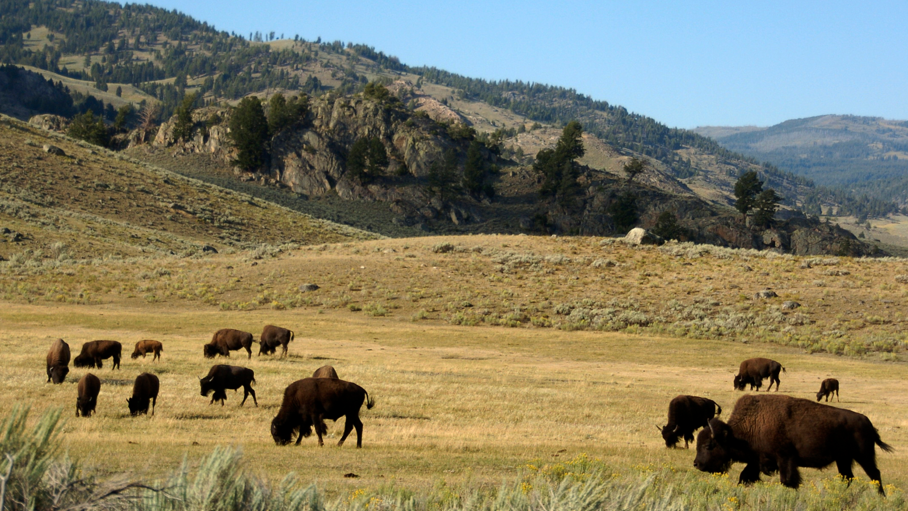

Group 6B Final Report

Group 6B: Lessons Learned from Restorative & Regenerative Projects including Bison and Grazing Animals

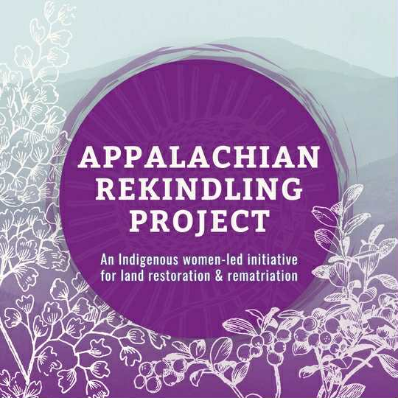
Appalachian Rekindling Project (ARP)
Contact: Tiffany Pyette

Group Members: Cecily Sperber, Dillon Jerke, Rachel Delorie, Sarah Jutson,
Stephanie Farmer, & Sara McLaughlin

ESS 440 Spring 2026

Land Acknowledgement
The Appalachian Rekindling Project is an intertribal nonprofit reintroducing Bison in central Appalachia to restore the rights of stewardship, sovereignty, and cultural connection. The lands involved in their bison return are the homelands of the Shawnee, the Cherokee, and the Yuchi peoples. Indigenous people from other territories also collaborate in this stewardship.

Abstract
The main rights-holder for this project is the Appalachian Rekindling Project (ARP), an intertribal nonprofit organization aiming to reintroduce Bison to their reclaimed native lands in Letcher County, Kentucky. The land has been severely degraded by historic coal mining in the area and was initially set to become a new prison, however, the ARP is instead working to restore the land and cultivate an Intertribal Indigenous center on the 63 acres of Appalachian terrain. This space will serve as a community center fostering relationships between Indigenous peoples, Indigenous homelands, and the culturally significant Bison. Before Bison can return to the land, however, the needs of both the land and animals must be met to ensure the Bison are mentally and physically healthy. Thus, prior to Bison introduction, the ARP has requested a report of wise-practices to best guide them in decision making processes for the introduction and ongoing care of Bison. The report will serve as a summary of lessons learned from restorative and regenerative projects including bison and other grazing animals. Information in this project was sourced from seven successful bison reintroduction projects and tailored specifically to the needs of the ARP.

Background
Coal mining in Eastern Kentucky, including Letcher County, began in the 19th century and has since caused significant land use change of mountainous regions and created accumulating ecological effects that still remain today. Mountaintop mining, the most common practice in this region, involves clearing all vegetation and topsoil from the area before using heavy machinery to remove bedrock up to 800 feet deep (Kentucky State University). The most direct effect of mountaintop removal mining is the degradation of land. Removal of topsoil and vegetation reduces biodiversity, affects net primary production, alters evapotranspiration rates, and increases rates of erosion. The loss of vegetation and severe disturbance to the ecosystem creates a land degradation cycle, where one effect of mining accelerates the other effects on the ecosystem. This is due to the interconnection between vegetation, wildlife, hydrology, atmospheric health, and soil health (Sahu & Dash, 2011). Land degradation, especially the loss of biodiversity, accelerates the issue of climate change and puts the long term productivity of the region at risk. The ecosystem will be less able to resist other disturbances and its resilience will be significantly impacted. In severe cases, this may lead to total ecosystem collapse (Ekka et al., 2023). Thus, land restoration efforts are vital to ensure the long-term sustainability of the ARP land in Letcher County.
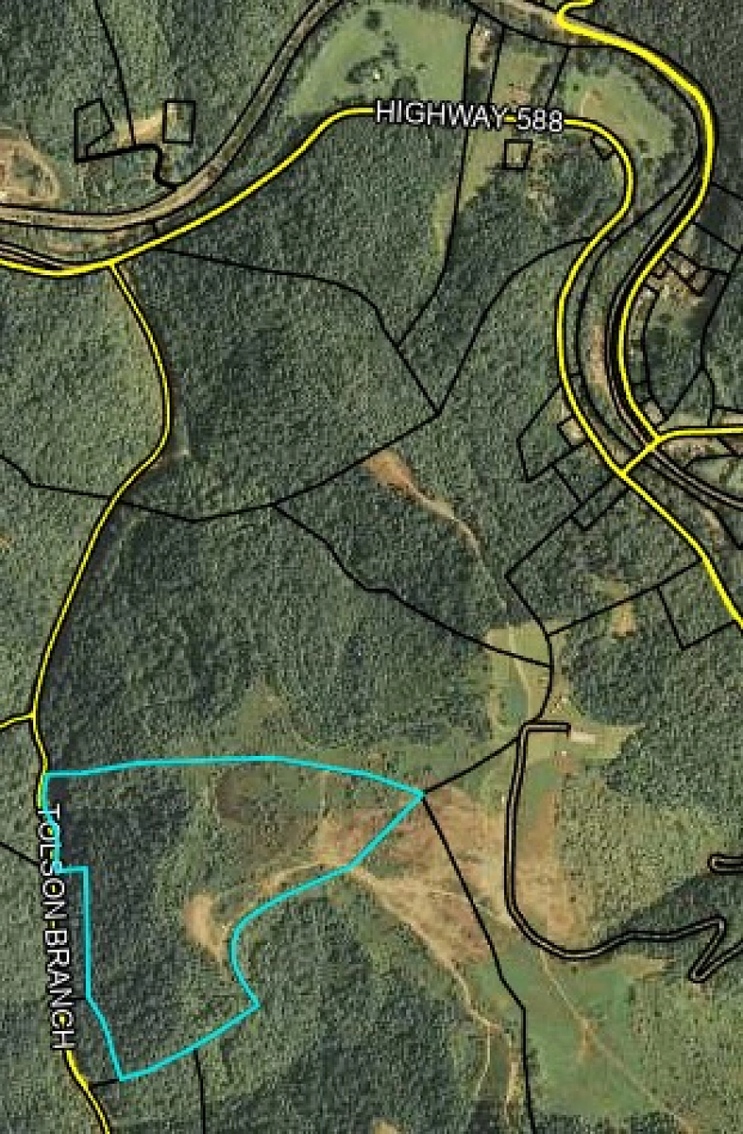
Figure 1. Map of ARP’s land (outlined in blue).

According to the 2022 U.S. Geological Survey, the dominant land cover of the ARP site in Letcher county is deciduous forest, meaning the region is predominately covered with trees that shed their leaves annually. Mixed and evergreen forests are also present within the area of interest. Local roads can be identified as the red/pink colors indicating development (figure 2). The eastern side of ARP’s property includes a patch of shrubby grassland, and is situated at the lowest part of the valley. All of these physical characteristics are essential for understanding the habitat the bison will be living in. The land cover can inform grazing, shelter, and potential hazards for ARP’s bison herd.
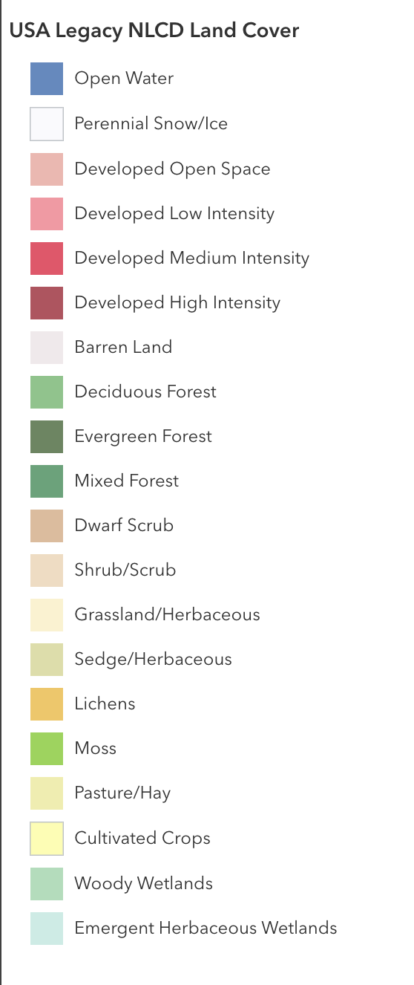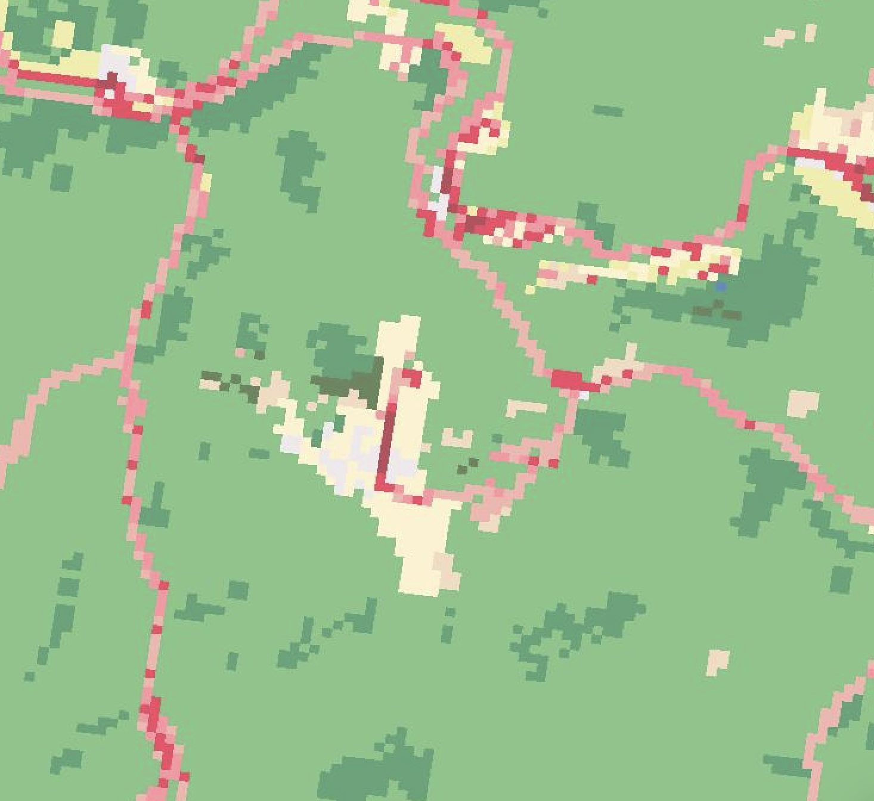
Figure 2. Land cover data for the approximate rematriation site area in Letcher County, Kentucky. Sourced from U.S. Geological Survey (USGS) National Land Cover Dataset.
The majority of Letcher County is located in the Eastern Kentucky Coal Field physiographic region, with the Eastern border belonging to the Cumberland Escarpment. The Eastern Kentucky Coal field is a part of the Cumberland Plateau, which extends all the way from Pennsylvania to Alabama. It is characterized by hilly forests and v-shaped valleys (Kentucky Division of Geographic Information, 2019). The entirety of the proposed rematriation site is within the Eastern Kentucky Coal Field, and follows these geomorphologic characteristics. The Kentucky Geological Survey further supports this land description when describing the county as “generally rugged”, with communities nestled in valleys (Carey et al., 2007).
Bison play a critical role in prairie ecosystems as keystone species that shape vegetation, soil processes, and overall biodiversity through grazing, movement, and nutrient cycling. Modern reintroduction efforts show that bison can help restore degraded landscapes by increasing plant diversity, improving soil health, and creating more resilient heterogeneous ecosystems. However, these outcomes depend heavily on management practices as factors like herd size, movement, and landscape context influence whether grazing is beneficial or harmful. Overall, bison based restoration highlights the importance of adaptive management and long term monitoring to ensure ecological recovery and sustainability.
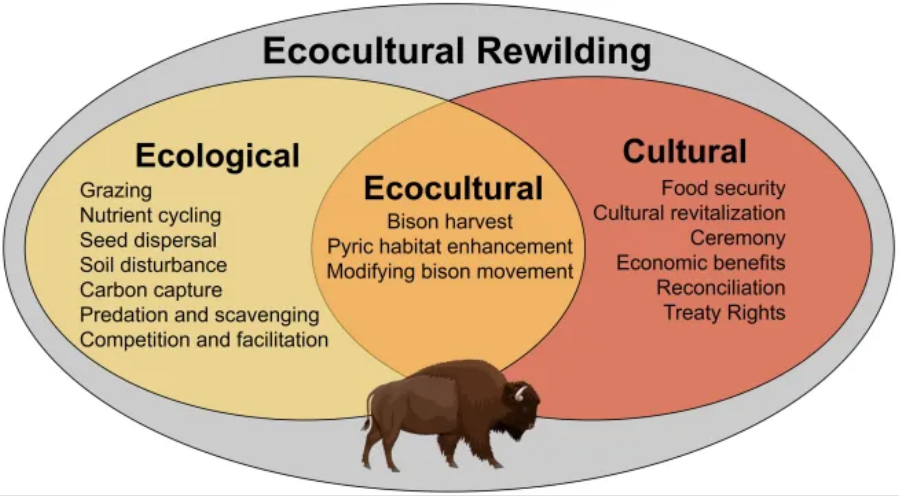
Figure 3. Ecological and cultural benefits of bison rewilding.
Grazing animals such as Bison, cattle, horses, sheep, and goats influence land cover and ecosystem processes through their feeding behavior, trampling, and nutrient deposition. Differences in digestive systems and grazing strategies shape how each species affects vegetation and soil. Ruminant grazers, like cattle, efficiently process fibrous plants, while horses consume larger volumes of vegetation, leading to distinct impacts on plant composition, soil structure, and nutrient cycling. Compared to bison, domestic grazers differ in grazing selectivity and movement across the landscape. Bison graze more broadly and promote heterogeneous vegetation patterns that support plant diversity, while cattle may reduce diversity if grazing is concentrated. However, cattle or horses can provide similar ecological benefits when managed through adaptive grazing practices (Kohl et al., 2013).
In forested and mixed land cover systems like those in eastern Kentucky, managed grazing has historically occurred and can support restoration goals. Grazing can control the dominant vegetation, encourage plant regrowth, and improve soil nutrient availability, particularly in degraded landscapes. When properly managed, grazing supports soil health and ecosystem function, making it a useful tool for ecological restoration (Teague & Kreuter, 2020).
Bison in particular play a central role in the cultural, spiritual, and social lifeways of Indigenous Peoples, serving as a foundation for identity, knowledge systems, and reciprocal relationships with the land (Smithsonian, 2018). Their near-extinction during U.S. westward expansion functioned as a deliberate colonial strategy that disrupted Indigenous economies, cultures, and sovereignty (Heuer et al., 2023). Contemporary restoration efforts, particularly through organizations like the InterTribal Buffalo Council, demonstrate that reintroducing bison can support cultural revitalization, ecological restoration, and community resilience. Overall, bison restoration highlights the importance of integrating Indigenous knowledge and leadership to promote both cultural and environmental sustainability.
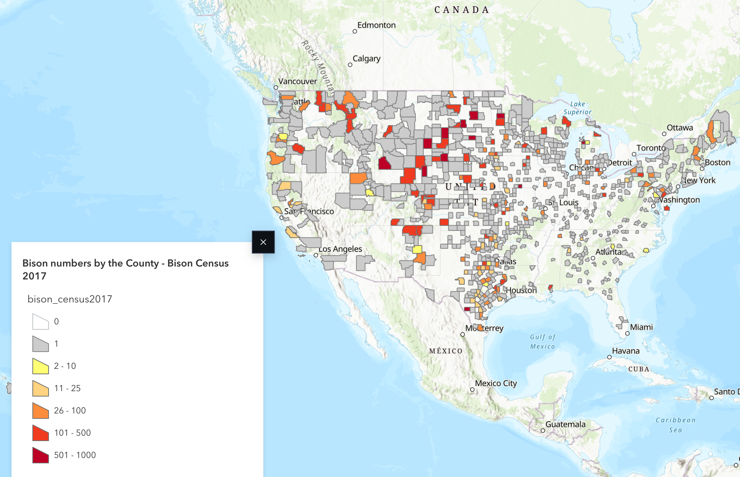
Figure 4. Bison abundance across counties in the U.S.
Unfortunately, the generally uneducated community perception of bison, reintroduction efforts, and fundraising pathways have historically affected the community response of bison reintroduction projects. Often, it is believed that animal introduction projects are a waste of money, time, or resources. Therefore, not many animal reintroduction projects are usually presented through a tax expense, leading to many projects failing early due to lack of effective fundraising. The lead author on a study evaluating European bison conservation and management states that “[a]nimal reintroduction projects face a high risk of conflict or lack of acceptance” (Tusznio et al., 2024). This provides reasonable evidence to conclude that many animal reintroduction projects, including bison reintroduction, struggle to meet communal acceptance and therefore may face issues with proper fundraising. Thus, ensuring efficient financial revenues will be a vital step for the ARP to ensure long-term success of reintroduction.

Methods
This project employed a qualitative, interview based research design to develop a wise practices list for the ARP. Data collection focused on semi-structured interviews with professionals in organizations engaged in bison restoration. A total of 14 organizations were selected from across the United States and international contexts to ensure a diversity of ecological, cultural, and operational perspectives. Interview questions addressed key aspects of bison management including herd logistics, land preparation, grazing and feeding practices, animal and land health, and financial considerations. When applicable, interviews also incorporated questions related to Indigenous community needs, priorities, and perspectives.
The analytical process began with the identification and selection of organizations, with an emphasis on projects involving Indigenous nation participation. Following selection, background research was conducted on each organization through review of relevant academic literature, reports, and publicly available materials. Interview protocols were then designed to address gaps in the existing literature, focusing on experiential knowledge and practices not well documented in written sources. In addition to remote interviews, field based observation was conducted during a site visit to the Soapstone Natural Prairie Area, where in person discussions with the head bison steward provided contextual and practical insights. Data analysis involved synthesizing interview findings with existing literature on bison restoration and Indigenous knowledge systems. Recurring themes, strategies, and challenges were identified across cases to inform the development of the final wise practices deliverable. This synthesis emphasized both ecological and cultural dimensions of restoration work.
The methodological approach logically followed from the initial background research and aligned with the needs of the Rights Holders. Prior literature review informed both the selection of interview participants and the development of targeted interview questions. By prioritizing firsthand accounts from practitioners actively engaged in bison restoration, the study centered lived experience and practical expertise. This approach ensured that the resulting analysis was grounded in real-world case studies and produced culturally relevant, community informed recommendations tailored to ARP’s goals with bison reintroduction in Letcher County, Kentucky.

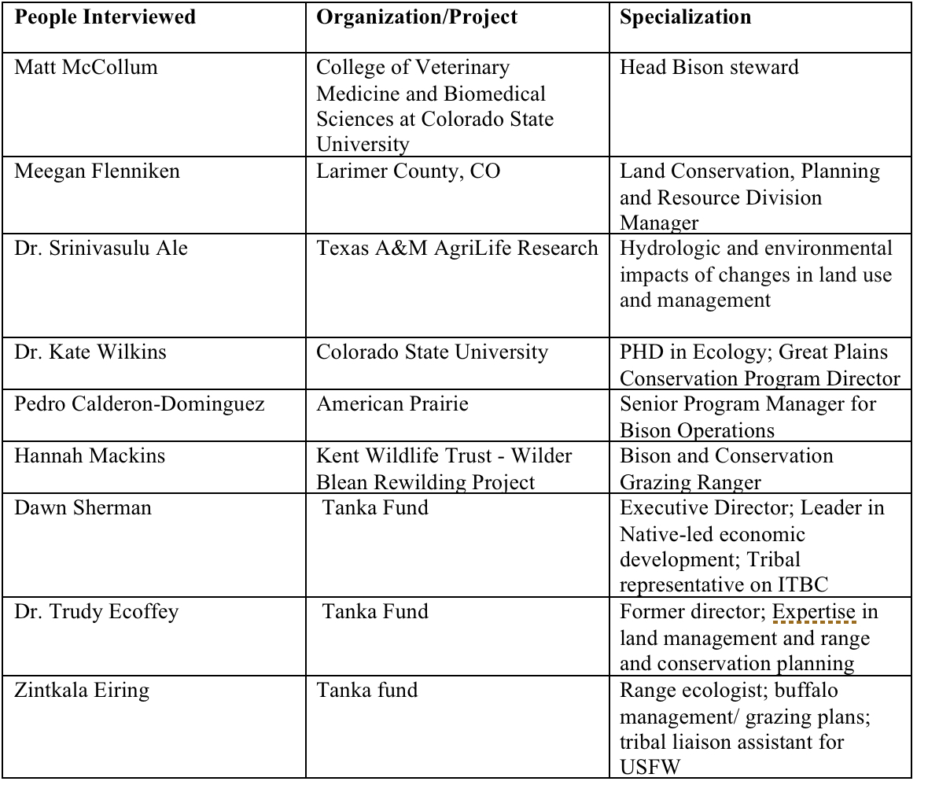
Table 1. List of professionals interviewed.

Results
We have configured our findings into a list of wise practices for the ARP. We compiled all interview responses by question, compared the results, and summarized the responses to compile a list, pulling the most repetitive and relevant information. We interviewed eight bison reintroduction projects across the world, including Texas, Colorado, Montana, and the United Kingdom. Five of the eight organizations were Indigenous-led. These organizations work with a variety of stakeholders and Indigenous rights-holders across the United States. The findings have been tailored to Appalachian Rekindling Project’s bison reintroduction goals in Southeastern Kentucky. The following are our results, presented in the form of a wise practices list:

Herd Logistics
Recommended Herd Size per Acreage:
- 4 to 6 acres per animal unit at minimum.
- Keep the total amount of animals to 50-60% of the land’s capacity. For example, if the land can support 13 bison, then do not keep more than 8 bison on the property. This will ensure bison health and happiness.
Recommended Number of Guardians per Bison:
- Start with 1 guardian per 4 to 8 bison. This guardian will check on all of the bison 2 to 3 times per week, ensuring the bison have enough water, are not injured, and have supplemental food if necessary.
  - Adjust the amount of guardians as the herd size increases to ensure all individuals are checked on 2 to 3 times per week.
Recommendations For Land Preparation Before Bison Introduction:
- Polluted water sources should be physically excluded from bison using fencing.
- Access to clean supplemental water sources should be available at all times.
- Prescribed burns are strongly recommended before bison return to land to prepare the site’s vegetation.
- Keep in mind that smaller pasture sizes require more management, as all space should be of high quality so the bison are not spatially limited.

Herd Population Management
Recommended Modes of Herd Expansion:
- Introduction Methods: Bison are social, so it’s wise to bring in 2-3 new individuals at a time (especially if they’re young). Quarantine new individuals away from the rest of the herd for the first 2-3 weeks. Ensure they are quarantined in a spot where they can see all other bison and can be watched by guardians at all times to adjust.
- Expansion by Reproduction: Bison reproduce every year; one bull can breed with 20-30 females per year. If a bull begins breeding with offspring, rotate the breeding bull out every 4-5 years to avoid inbreeding issues.
- Expansion by Outsourcing: National parks, bison refuges, trade with other Indigenous Nations
Recommended Modes of Herd Downsizing:
- Downsizing may be necessary if land is overgrazed or reproduction rate is faster than proper care and land acreage allows for. Outsourcing options include donating animals to other Indigenous Nations, bison refuges, or harvesting animals for cultural purposes.

Grazing and Feeding
Rotational Grazing Recommendations:
- Scheduled rotational grazing is largely unnecessary for this project considering the site’s low acreage.
- Low-stress handling rotation can be considered on an as-needed basis if the entire herd remains in one spot to the point of overgrazing.
- Rotational grazing frequency will increase if supplemental feed is not provided.
Potential Overgrazing Issues:
- Bison will pick their favorite places of the land and spend a lot of time there. The land can degrade it if they spend too much time in one place.
- During calving season, the entire herd will gather in areas with hills or large grass cover until babies are born, which can lead to overgrazing.
- Bulls older than 9 years will set territory right after breeding season, which can lead to overgrazing.
Potential Overgrazing Solutions:
- Implement rotational grazing practices (see “Rotational Grazing Recommendations”).
- Low stress bison handling movement: Teach bison to move as a herd when needed (can train with treats), but behave naturally otherwise.
- Reduce herd size (see ”Recommended Modes of Herd Downsizing”).
- Expand land acreage: Bison breed fast, so if there are no plans to expand the land it is recommended to not breed consistently.
Fencing and Bison Escape:
- Bison require both fencing for enclosure and corrals for movement. A corral is necessary for handling during annual veterinary inspections. ARP may choose to configure fencing heights to enclose bison, but allow other wildlife crossing (ex: deer, elk, etc.). This height will depend on local wildlife present and is subjective to ARP’s preferences.
- Fencing can be created from a variety of materials, including 5-strand wire, 3-inch piping, and steel rods. Fencing material may vary depending on budget.
- Create a bison escape plan before the bison herd arrives on site. Share this plan with neighbors and nearby landowners to reduce fear surrounding potential bison escape.
- Tag bisons to monitor their specific behavior. Being able to easily track select bison is advantageous for health purposes.

Animal and Land Health
Supplemental Needs:
- Annual vet checks for the bison to ensure wellbeing. (there are options to partner with a local universities)
- Supplemental feed may be necessary if vegetation levels are not sufficient. Vegetation is considered insufficient if over 25% of plant production on the land is grazed.
Indicators of Improved Land Health Post-Bison Reintroduction:
- Improved vegetation diversity and abundance
- Improved soil health and soil carbon sequestration
- Improved water quality
- Reduced erosion and runoff
- Increased nutrient cycling and availability
- Increased fertilization
- Newly created small wallows/ wetlands for seed germination
- Perennial grasses return
- Improved wildlife diversity
Monitoring Bison Reintroduction Success:
- Monitor bison health to ensure no bison is hurt during reintroduction.
- Measure reproductive success by tracking how many calves are born per year. It is expected that every healthy, mature cow will deliver offspring every breeding season.
- Track any disease to ensure low contraction rates.
- Annual veterinary checks for each individual should be conducted to verify the health of the overall herd.
- Look for signs of bison happiness. A happy bison herd will not try to escape, and will utilize the entire landscape provided for them.

Financial Considerations
Unexpected Costs to Be Aware Of:
- Fencing can be extremely expensive, as well as repairs.
- A bison corral costs about $1,500 per bison.
Common Funding Options:
- Donations and fundraising campaigns
- Income from harvesting bison
- Intertribal Buffalo Council (ITBC)
- Tribal Partnerships Program of the National Wildlife Federation
- U.S. Department of Agriculture (USDA)
- World Wildlife Fund (WWF)
- U.S. Department of Interior via Bison Conservation Initiative
- U.S. Fish and Wildlife Service

Community Engagement
Options for Engaging Local Community Members:
- Hold an opening event showcasing the bison, project initiatives, and safety and education briefings.
- Get to know the neighbors and the surrounding livestock. Explain the rarity of bison escape and share the bison escape plan set in place in case of emergency.
- Educate local schools and families via visits, local, media outlets, infographics, and word of mouth.

External Resources
Partnerships to Consider:
- Intertribal Buffalo Council (ITBC)
- City land manger
- USDA local service center
- Local veterinarians or vet schools
- University of Kentucky
External Resources For Additional Information:
- National Bison Association (NBA)
- National Resource Conservation Service (NRCS)
- American Prairie

Additional Information About Interview Sources
Matt McCollum - Bison Herd Manager for College of Veterinary Medicine and Biomedical Sciences at Colorado State University.
Meegan Flenniken - Land Conservation, Planning and Resource Division Manager for Larimer County, Colorado.
Dr. Srinivasulu Ale - Ph.D FISAE Professor of Agrohydrology at Texas A&M AgriLife Research. Vernon, Texas.
Dr. Kate Wilkins - PHD research on how bison reintroduction affects birds, mammals, vegetation communities, and people who visit reintroduction sites. Colorado State University, Fort Collins, Colorado.
Pedro Calderon-Dominguez - Lead bison guardian at the American Prairie, a Tribal organization with Bison on approximately 70,000 acres of Prairie land. Phillips County, Montana.
Hannah Mackins - Bison Ranger with Wilder Blean Rewilding Project, a UK-based rewilding project reintroducing European bison as ecosystem managers.
Dawn Sherman, Zintkala Eiring, and Dr. Trudy Ecoffey- Executive Director, Range Ecologist, and former director of the Tanka Fund, an Indigenous-led organization working to reintroduce buffalo on Native-owned ranches. Rapid City, South Dakota.
Eastern Shoshone Tribe - A large Tribal organization with a 300 acre bison enclosure on plains and rolling hills. Fort Washakie, Wyoming.
Wolakota Buffalo Range of the Sicangu Lakota Nation - A large Tribal organization with over 1,200 bison on 28,000 acres; the largest Native-owned bison herd in the States. Rosebud Indian Reservation, South Dakota.

Conclusions
Overall, our group developed a wise practices guide that brings together lessons learned from multiple bison reintroduction and land restoration projects and applies them to the ARP’s goals in eastern Kentucky. By comparing different projects and interviewing experts, we identified key recommendations for herd management, land preparation, monitoring, and community engagement that support both ecological health and cultural values.
Our final outcome is a practical and adaptable resource that ARP can use as they introduce their initial herd of bison and continue to expand their restoration efforts. Rather than creating strict rules, our guide focuses on flexible strategies that can be adjusted over time as the herd grows and the land responds. We recommend that the ARP prioritizes ongoing monitoring of both the bison health and land conditions, maintain a conservative herd size relative to the land capacity, and continue incorporating cultural and community perspectives into their decision making.
Looking forward, future directions could include expanding monitoring efforts through partnerships with universities or research institutions, especially to track long term changes in soil health, vegetation, and biodiversity. As the herd grows, ARP may also consider adapting grazing strategies or expanding land access to prevent overgrazing and maintain ecosystem balance.

Final Deliverables
The full list of wise practices, presentation, and infographic are uploaded separately.

References
Barber, N. A., Klimek, D. M., Bell, J. K., & Swingley, W. D. (2023, January 20). Restoration Age and Reintroduced Bison May Shape Soil Bacterial Communities in Restored Tallgrass Prairies. Oxford Academic. FEMS Microbiology Ecology. https://academic.oup.com/femsec/article-abstract/99/3/fiad007/6994523
Carey, D. I., Webb, S. E., & Davidson, B. (2007). Generalized geologic map for land-use planning: Letcher county, Kentucky. Kentucky Geological Survey, University of Kentucky. https://doi.org/10.13023/KGS.MC183.12.
David-Chavez, D. & Layden T. (2025). Language matters: Building respectful, culturally responsive writing and communication practices, Indigenous Land and Data stewards Lab.
Ekka, P., Patra, S., Upreti, M., Kumar, G., Kumar, A., & Saikia, P. (2023). Land degradation and its impacts on biodiversity and ecosystem services. Land and Environmental Management through Forestry, 77–101. https://doi.org/10.1002/9781119910527.ch4
Heuer, K., Farr, J., Littlebear, L., & Hebblewhite, M. (2023). Reintroducing bison to Banff National Park–an ecocultural case study. Frontiers in Conservation Science, 4, 1305932.
Jeff Martin, Ph. D. ; B. W.-T. (2021, August 25). Bison by the numbers. ArcGIS StoryMaps. https://storymaps.arcgis.com/stories/6cc9ee1b777447128d811238babfe1ed
Kentucky Division of Geographic Information. (2019, April). Physiographic regions in the commonwealth of Kentucky. Kentucky Geological Survey. https://kygeonet.ky.gov/StoryMaps/KyPhysiographicRegions/
Kentucky State University. (n.d.). Surface mining and quality of life in Appalachian region. https://www.kysu.edu/academics/college-ahnr/school-of-anr/ag-res/surface-mining-and-quality-of-life-in-appalachian-region.php
Kohl, M. T., Krausman, P. R., Kunkel, K., & Williams, D. M. (2013). Bison Versus Cattle: Are They Ecologically Synonymous? Rangeland Ecology & Management., 66(6), 721–731. https://doi.org/10.2111/REM-D-12-00113.1
Martin, J. (2021, August 13). Bison by the Numbers. Storymaps.arcgis.com.https://storymaps.arcgis.com/stories/6cc9ee1b777447128d811238babfe1ed
Ratajczak, Z., Collins, S. L., Blair, J. M., & Nippert, J. B. (2022, August 29). Reintroducing Bison Results in Long-Running and Resilient Increases in Grassland Diversity. PNAS. https://www.pnas.org/doi/10.1073/pnas.2210433119
Sahu, H. B., & Dash, S. (2011). Land degradation due to mining in India and its mitigation measures. In Proceedings of the Second International Conference on Environmental Science and Technology (ICEST 2011), Singapore.
Smithsonian National Museum of American Indian. (2018). Taking Informed Action: InterTribal Buffalo Council. InterTribal Buffalo Council. https://americanindian.si.edu/nk360/plains-belonging/itbc
Steenweg, R., Hebblewhite, M., Gummer, D., Low, B., & Hunt, B. (2016, February 24). Assessing Potential Habitat and Carrying Capacity for Reintroduction of Plains Bison (Bison bison bison) in Banff National Park. PLOS. https://journals.plos.org/plosone/article?id=10.1371%2Fjournal.pone.0150065
Teague, R., & Kreuter, U. (2020). Managing grazing to restore soil health, ecosystem function, and ecosystem services. Frontiers in Sustainable Food Systems, 4, Article 534187. https://doi.org/10.3389/fsufs.2020.534187
Tusznio, J., Gutierrez, L. S., Strzelecka, M., Niedziałkowski, K., & Grodzińska-Jurczak, M. (2024). Traditional and emerging visions of European bison (Bison Bonasus) conservation and management: Implication for the IUCN Conservation Planning. Environmental Science &amp; Policy, 158, 103783. https://doi.org/10.1016/j.envsci.2024.103783

